Youghal Irish Needle Lace
Elizabeth M. Kurella
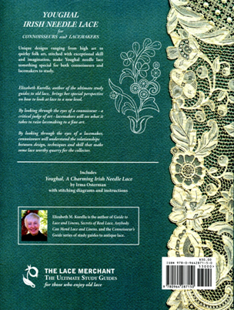
Elizabeth Kurella skillfully presents a new book that will be of use to both lace connoisseurs and lacemakers. She explains the book title in her Introduction: "One discovery I made many years ago on my first foray into a congress of lacemakers was that for some unknown reason lacemakers and lace collectors did not easily mix. Decades later I still do not understand why many collectors seem terrified of trying the process of lacemaking, and lacemakers fear finding things in the real world that don't match up with their expectations of whatever the 'rules' of lacemaking should have been."
When we take time to think about this, learning the skills is useful in evaluating a piece of lace. And for the maker, having an understanding of traditional laces inherited, presented at auctions or sales, or to be studied in wonderful lace collections, has merit.
In Elizabeth's 3-page Introduction, we are introduced to Youghal lace in a generous and gracious manner. Youghal needle lace was developed in the mid-19th C., by which time machines were giving all hand-made laces a brutal level of competition, and hand-made needle laces made on the European Continent were at an advantage because they were well established.
Many lace collectors have difficulty identifying laces, and so it is gratifying to have six pages devoted to this, with detailed photographs in the Elizabeth Kurella style we have come to appreciate in her previous books.
Designs are important to the overall effect and success of lace. This new book features a large lace flounce owned by the author, worked from 19th C. designs by Sister Mary Regis of Youghal. Throughout, this collection of lovely designs is presented in line drawings, taken directly from this flounce. (For more about Sister Mary Regis and her designs, see the late Pat Earnshaw's two books "Youghal and Other Irish Laces" and "Youghal Lace - the Craft and the Cream".)
In a stroke of genius, Elizabeth arranged with the family of the late Irma Osterman to reprint her book "Youghal - A Charming Irish Needle Lace", as an appendix. It consists of 29 pages of stitch instructions. The original Osterman book is out-of-print.
There is a bit of history about Alan S. Cole (1846-1934) who published photographic research and scholarly reports about laces, with a focus on developing and promoting good design in Irish and English laces.
Jeri Ames

